

**Mathematics Methods  
YEAR 11**

**Investigation 2 – Pascal’s Triangle and Binomial Expansion**

**Semester 1 2019**

**Time allowed:** 40 minutes

**Marks Available:** 38 marks

**Materials required:** Writing implements, correction fluid/tape or eraser, ruler, Scientific calculator

**Instructions:**

1. Write your answers in the spaces provided in this Question/Answer Booklet.
2. **Show all your working clearly**. Your working should be in sufficient detail to allow your answers to be checked readily and for marks to be awarded for reasoning. Incorrect answers given without supporting reasoning cannot be allocated any marks. For any question or part question worth more than two marks, valid working or justification is required to receive full marks. If you repeat an answer to any question, ensure that you cancel the answer you do not wish to have marked.

**Part A (7 marks)**

The diagram is Pascal’s Triangle. Each number in the triangle is obtained by adding the numbers right and left above it. Rows 0 to 3 have been done. Complete the remaining rows.

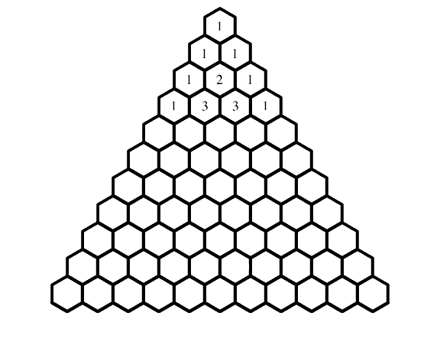

Space for working if needed

**Part B (31 marks)**

# Algebraic Expansions

Remember having to expand an expression like

**(1 + x)2**

As a reminder, the expression is expanded like this:

**(1 + x)2 = (1 + x)(1 + x)**

**= 1 + 2x + x2**

In the middle pair of brackets, each term in the left bracket is multiplied by each term in the right bracket.

We can do the same with a cube, i.e (1 + x)3. Verify that the following is correct.

**(1 + x)3 = (1 + x)(1 + x)(1 + x)**

**= (1 + x)(1 + 2x + x2)**

**= 1 + 3x + 3x2 + x3**

1. (1 mark)  
   Comment on the **coefficients** (the numbers on their own and in front of the x's) of the results. [1]
2. (4 marks)  
   Prove, using algebra, that, [4]
3. **+ x)4 = 1 + 4x + 6x2 + 4x3 + x4**
4. (4 marks)  
   Prove that the expansion of (2 + 3x)5 is **32 + 240x + 720x2 + 1080x3 + 810x4 + 243x5**
5. (12 marks)  
   Using the Pascal’s Triangle, simplify the following binomials showing all working steps:
6. ${\left(x+3\right)}^{4}$ [4]
7. ${\left(x-1\right)}^{6}$ [4]
8. ${\left(2x-y\right)}^{3}$ [4]
9. (2 marks)  
   a. What is the coefficient of $x^{4}y^{6}$ in the expansion ${\left(x+y\right)}^{10}$? [1]

b. Which other term has the same coefficient as ? [1]

6. (8 marks)  
Write down each of the following:

a. the third term of ${\left(x+y\right)}^{11}$? [2]

b. the fifth term of ${\left(x-y\right)}^{7}$? [2]

c. the 6th term of ${\left(x-1\right)}^{9}$? [2]

d. the 4th term of ${\left(x-\frac{1}{x}\right)}^{10}$? [2]

**End of Investigation**